**ERASMUS KA 220 VET “THERMA-SAT FARMING” TRANSNATIONAL MEETING**

**PROJECT MEETING’S MINUTES**

***13-14 November 2024 – Swarożyn, Poland***

The project partners came together on 13-14 November in Swarożyn at ZESPÓŁ SZKÓŁ CENTRUM KSZTAŁCENIA ROLNICZEGO IM. STANISŁAWA STASZICA to discuss the project’s implementation process for the first year, make decisions about upcoming mobility dates and planning the production of the project results. Marta Gulgowska moderated the meeting with the assistance of Gülşen Topçu for all participants. Vincenzo Contu and Davide Casu (Sardinia, Italy), Ercüment Aksoy and Gülşen Topçu (Antalya, Turkey AIR3DMAP Company), Mustafa Özel and Tamer Balkan (Antalya, Turkey Muratpaşa MTAL), Gabrijela Čorković and Lucija Baškarić (Zagreb, Croatia), Soare Catalin, Vatafu Ioana Madalina and Vatafu Tiberiu Vicentiu (Dragaşani, Romania) joined the meeting as the representatives of partner schools. Piotr Popielarczyk headmaster of the school and Marzena Grodek from financial department also joined the meeting from host school.

The following topics have been discussed and decisions made by consensus.

1. The tasks and responsibilities were distributed according to capacity and profile of each partner based on the application form of the project. For **WP 1 Project Management;**

**Zespol Szkol Centrum;**

* will coordinate, provide effective communication among all partners, supervise planning,

* do budget control, time sheets preparement with the help of AIR3DMAP and allocate tasks

* provide implementation, evaluation, dissemination of all the project activities and products, compose the final report, disseminate all main project's outcomes on the EU Dissemination Platform

**All partners will be responsible for:**

*local, regional and national cooperation with own stakeholders and educational institutions;

*dissemination, communication;

*publications, participating to the study material and manuals composing;

*implementing the project activities, participating the transnational project meetings, preliminary tasks to ensure *successful meetings;

*ensuring academic level of activities.

The proving documents for costs (invoices for tickets, accommodation invoices etc. will be uploaded to drive file by partners, drone invoices and project implementation invoices will also be uploaded)

**WORK PACKAGE 2 BASIC UAV TRAINING AND DRONE KIT DESIGN**

**1-BASIC UAV TRAINING KIT**

M1: Technologies, Aerodynamics and Performance. **(ISTITUTO TECNICO COMMERCIALE "1-2 G.P. CHIRONI-S. SATTA)**

M2: Propulsion Systems. **(ISTITUTO TECNICO COMMERCIALE "1-2 G.P. CHIRONI-S. SATTA)**

M3: RC, Avionics and Display Systems. **(ISTITUTO TECNICO COMMERCIALE "1-2 G.P. CHIRONI-S. SATTA)**

M4: Autonomous Flight and Ground Station Systems. **(ISTITUTO TECNICO COMMERCIALE "1-2 G.P. CHIRONI-S. SATTA)**

M5: Civil Aviation rules. **(ZESPOL SZKOL CENTRUM)**

M6: Meteorology and Flight Safety. **(ZESPOL SZKOL CENTRUM)**

M7: Basic Level Design. **(LICEUL TEHNOLOGIC BRATIANU)**

M8: Maintenance and Repair. **(LICEUL TEHNOLOGIC BRATIANU)**

M9: Using a Drone with special equipment (thermal and multispectral camera) **(AIR3DMAP COMPANY)**

M10: Softwares and applications to analyze images gathered by drone (analysis of thermal images for agricultural purposes) **(AIR3DMAP COMPANY)**

**2-DRONE DESIGN-PRODUCTION GUIDE**

M1-Different types of multi-rotor UAVs **(AIR3DMAP COMPANY)**

M2-Flight terminology Roles of ESC **(AIR3DMAP COMPANY)**

M3-Drone flight **(AIR3DMAP COMPANY)**

M4-LiPo batteries **(AIR3DMAP COMPANY)**

M5- GPS in flight **(ZESPOL SZKOL CENTRUM)**

M6-Radio receiver and transmitter systems **(ZESPOL SZKOL CENTRUM)**

M7-Pre-flight checks **(LICEUL TEHNOLOGIC BRATIANU)**

M8-Assembling a quadcopter from commercially available parts **(LICEUL TEHNOLOGIC BRATIANU)**

M9-Required Software and controller **(ISTITUTO TECNICO COMMERCIALE "1-2 G.P. CHIRONI-S. SATTA)**

M10-Basic safety and legal requirements **(ISTITUTO TECNICO COMMERCIALE "1-2 G.P. CHIRONI-S. SATTA)**

**Agronomska skola Zagreb will be responsible for evaluation and testing of the learning modules. The school will prepare the module evaluation forms to be applied after the piloting of the modules on students and prepare the reports.

**3-WORK PACKAGE 3: REMOTE SENSING AND IMAGE PROCESSING KIT AND TRAINING MODULES**

**1- Remote Sensing and Image Processing Kit and Training Modules**

1.Image Processing Techniques, data mining and machine learning. **(LICEUL TEHNOLOGIC BRATIANU)**

2. Fundamentals of Remote Sensing **(ISTITUTO TECNICO COMMERCIALE "1-2 G.P. CHIRONI-S. SATTA)**

3. Electromagnetic Spectrum **(ISTITUTO TECNICO COMMERCIALE "1-2 G.P. CHIRONI-S. SATTA)**

4. UAV and UAV Imaging Technologies **(LICEUL TEHNOLOGIC BRATIANU)**

5. Satellite and Satellite Imaging Technology **(AIR3DMAP COMPANY)**

6. Data Sources (ESA, GEE, NASA, OSM) **(AIR3DMAP COMPANY)**

7.Downloading / Obtaining Image Data **(AIR3DMAP COMPANY)**

**2-Learning Modules related to Smart farming via Image Processing**

1.Using thermal imaging technology in agricultural applications. **(ISTITUTO TECNICO COMMERCIALE "1-2 G.P. CHIRONI-S. SATTA)**

2.Obtaining land use types of agricultural fields by applying image processing to satellite images. **(ZESPOL SZKOL CENTRUM)**

3.Soil Properties via thermal and satellite imaging **(AIR3DMAP COMPANY)**

4.Drone Image Analysis for Crop Damage Assessment **(LICEUL TEHNOLOGIC BRATIANU)**

5.Heat maps of fields obtained by thermal-infrared image processing. **(AIR3DMAP COMPANY)**

**Agronomska skola Zagreb will be responsible for evaluation and testing of the learning modules. The school will prepare the module evaluation forms to be applied after the piloting of the modules on students and prepare the reports.

**4.** It was indicated in the proposal that 20 persons (students-teachers) per partner, in total 100 persons will get drone licence. This training should be provided to 20 students and teachers from each partner school. Partners will organize the training locally.

AIR3DMAP suggested the partners to organize the training as summer school in Antalya in July coordination with Akdeniz University Aviation Training Center (Accredited drone training center). Partners can use their KA1 budgets or accreditation budgets for the costs. The training cost is per participant 50 Euros apart from travel and accommodation cost. Partners will decide and inform AIR3DMAP about their decision.

Sardinian partner also suggested to take the free online course provided by **Euro control** for the license. Partners will decide and complete the training within the project lifetime.

**5-**For the exceptional cost budget Thermaldrone the same model will be bought by all partners. **(DJI MAVIC 3 T)** was recommended by the Italian partner, other partners will search their local market and buy the similar drone till the end of March latest. The properties of drone is as following;

**\* 12 MP Wide Angle Camera**

**\* 48 MP Zoom Camera with 5x-16x Optical Zoom and 200x Digital Zoom support.**

**\* Night Vision FPV Camera with 1920x1080p resolution**

**\* 640 × 512 resolution Thermal Camera with +/- 2 °C temperature accuracy.**

**\* Thermal Insights: Point and field temperature; high temperature warnings; colour palettes; isotherms**

**\* Laser Range Finder that can measure between 3-1200 metres**

**\* RC Plus control with IP54 protection**

**\* 15 Km Control range distance**

**\* Wind resistance up to 12 m/s**

**\* Up to 41 minutes flight time with dual battery.**

**\* Maximum take-off weight of 4 kg**

**\* Ability to work between -20 and 50 degrees**

**\* 6-way obstacle detection.**

**\* IP 55 Protection**

**\* Wireless fast charging with the latest generation DJI Dock System**

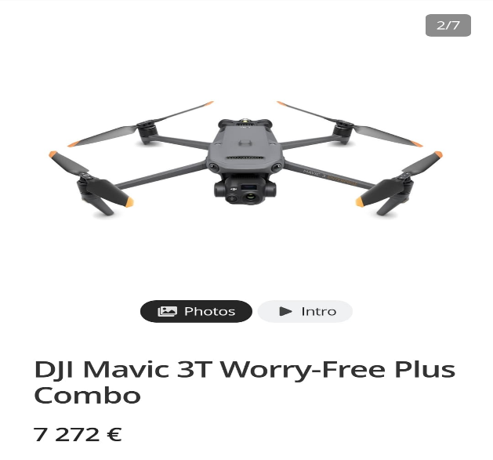

\***Suggestion of Italian partner**

**\***For the software free open sources will be used by the partners. AIR3DMAP will guide the partners in usage of open sources.

**6. The mobilities for the first year discussed and dates were determined as following;**

**1-** The first LTT for teachers **“Train the trainer event”** will be organized on **26 January-1 February** in Antalya under the responsibility of AIR3DMAP Company. The host partner will prepare an info pack including meeting agenda and invitation letters and share with the partners as soon as possible. 3 teachers from each partner will join the event.

**2-** The second LTT with students will be organized on in Nuoro -Sardinia **on 30 March- 5 April** under the responsibility of ISTITUTO TECNICO COMMERCIALE "1-2 G.P. CHIRONI-S. SATTA". The host partner will prepare an info pack including meeting agenda and invitation letters and share with the partners at least one month before the mobility. 5 students and 2 teachers from each school partner will join the event.3 teachers/staff from AIR3DMAP Company will also join.

The mobilities for 2025-2026 educational year will be planned later.

|  |  |  |
| --- | --- | --- |
| Piotr Popielarczyk  Marzena Grodek | Marta Gulgowska | Gülşen Topçu Ercüment Aksoy |
| **ZESPÓŁ SZKÓŁ CENTRUM KSZTAŁCENIA ROLNICZEGO IM. STANISŁAWA STASZICA** | | **AIR3DMAP COMPANY** |
| Vincenzo Contu Davide Casu | | Tamer Balkan Mustafa Özel |
| **(ISTITUTO TECNICO COMMERCIALE "1-2 G.P. CHIRONI-S. SATTA)** | | **MURATPAŞA MTAL** |

Soare Catalin Vatafu Ioana Madalina Vatafu Tiberiu Vicentiu Gabrijela Čorković Lucija Baškarić

**LICEUL TEHNOLOGIC BRATIANU AGRONOMSKA SKOLA ZAGREB**